1. Retrieve data from eFC Task List Report
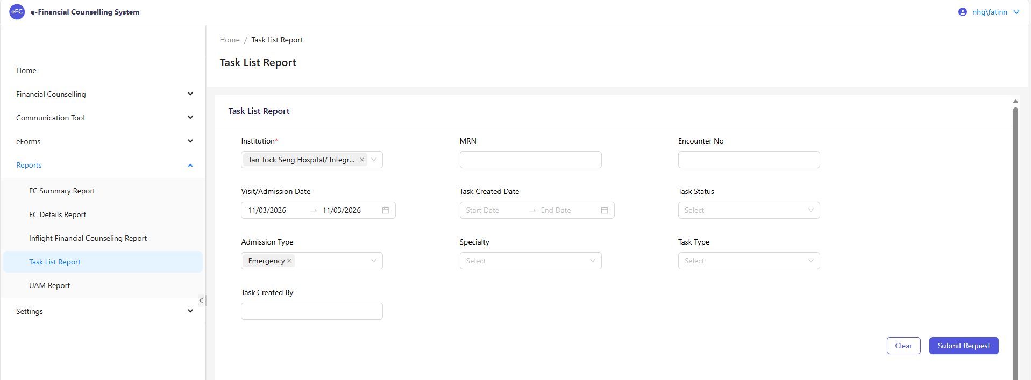
- Go to eFC > Reports > Task List Report
- Enter Required Filters
- Visit/Admission Date: One day before today
- Admission Type: Emergency

2. Generate Report
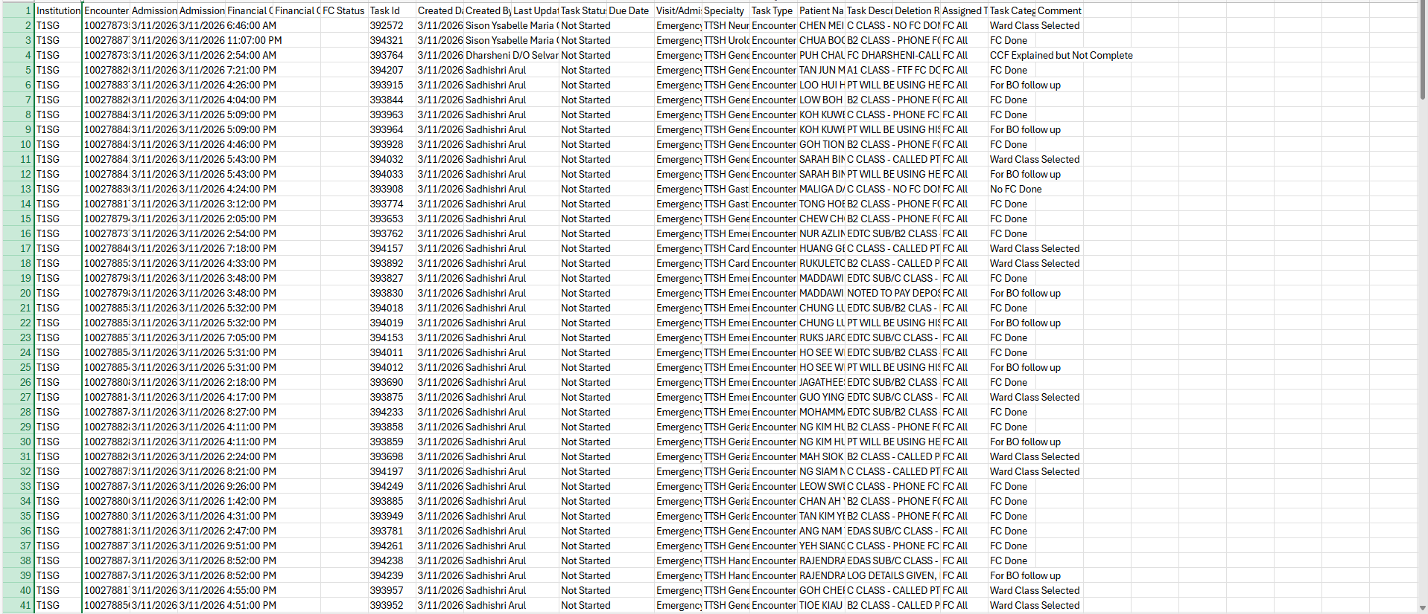
- Keep the original copy
- Create a new sheet

3. Filter the cases
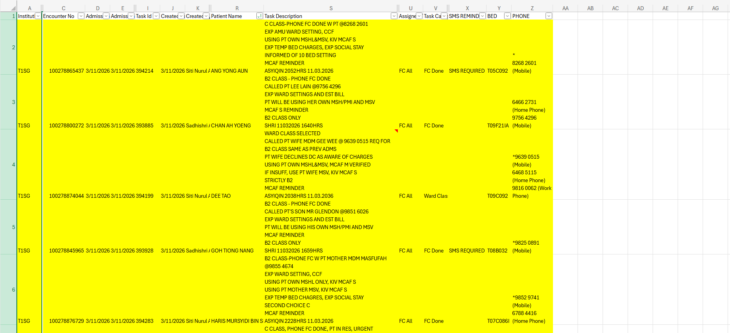

- Insert a new column labelled “MCAF Reminder”
- Use an IF formula to identify cases that require SMS notification by extracting information from the ED Comments field.
- Example: If “FC DONE” and “MCAF REMINDER” are found in the ED comments, the system will display “SMS REQUIRED”
- Add Additional Information Columns: BED NUMBER and PHONE NUMBER
- Use XLOOKUP to retrieve the relevant information from the Epic Reports.

Identify Cases of SMS Notification
- Cases with FC DONE / PHONE FC DONE and MCAF REMINDER in the comments require an SMS to be sent to the NOK.
- Cases with NO FC DONE / WARD CLASS SELECTED – will appear in the Inflight Report and will require FC follow-up.

4. Use the SMS Template

After filtering cases marked as “SMS REQUIRED”:

- Refer to Kenzo’s SMS Template and create a new worksheet.
- Copy and insert the cases that require SMS notification.
- Ensure the correct phone numbers are included for each case.

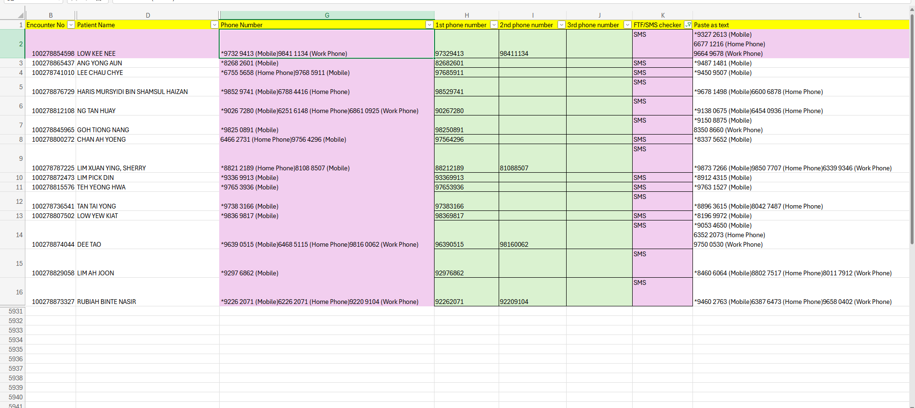

5. Excel sheet for SMS Broadcast

- Create a new Excel Sheet worksheet for the SMS broadcast list.
- Extract and input the mobile phone numbers only.
- Ensure each phone number is listed in a single row under the Mobile column.
- Verify that all numbers are correct before sending the SMS broadcast.
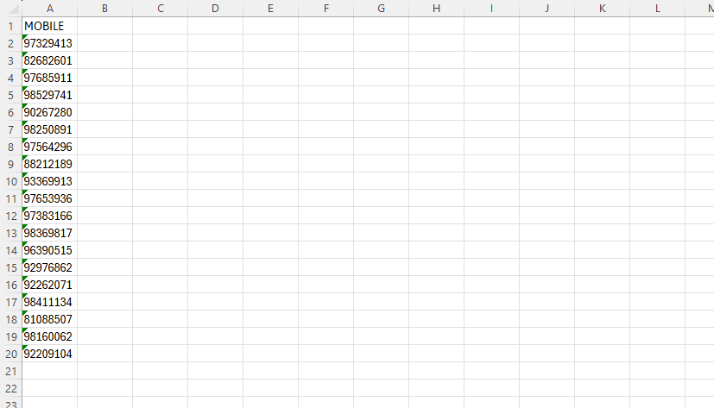

6. Access https://nhgemsvpweb01.nhg.local/ems/portal/login.php and login with Email Address and Password.

7. Select ‘Send Message’ followed by ‘Broadcast SMS’.

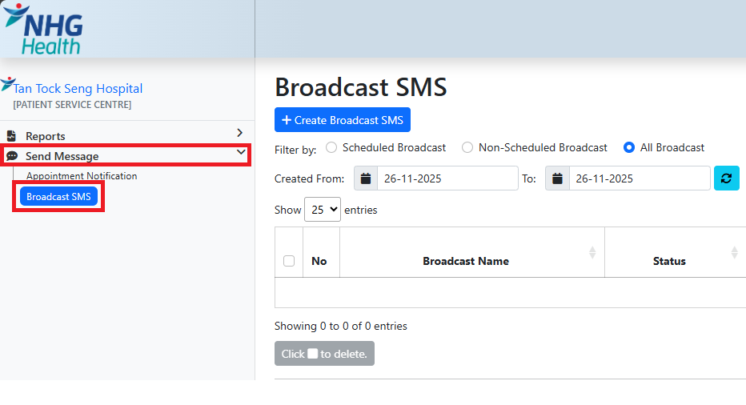

8. Click ‘Create Broadcast SMS’
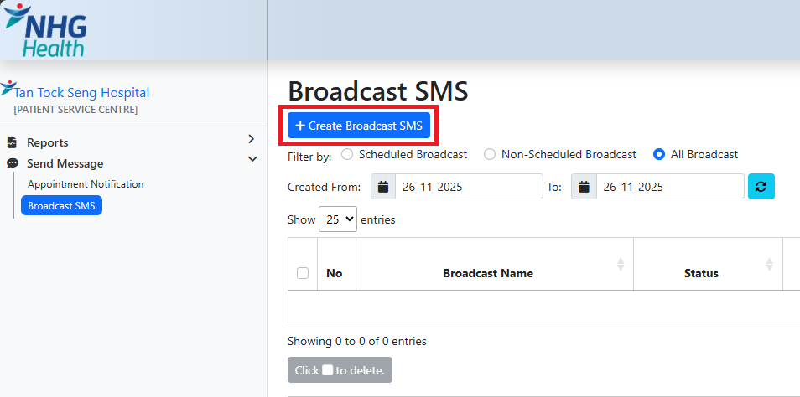

9. Click ‘Create Broadcast SMS’: Complete the required fields

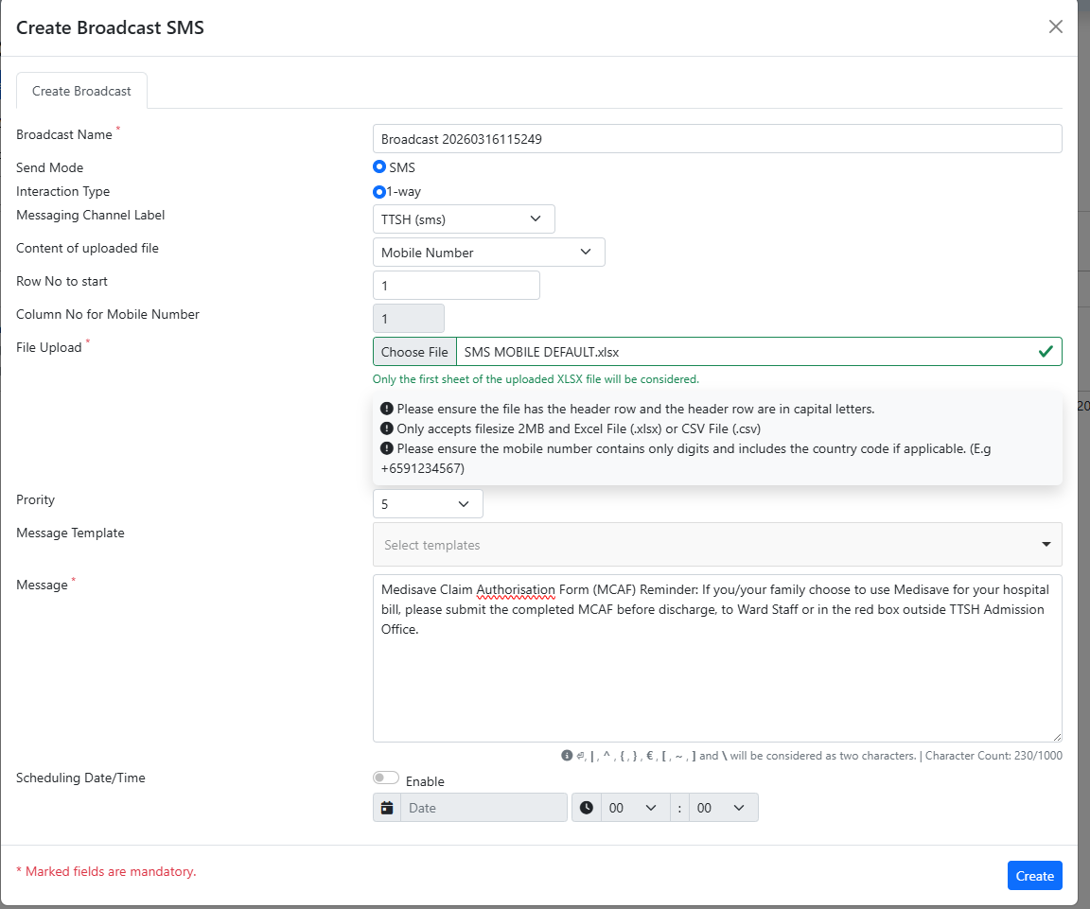

- Content of uploaded file: Mobile Number
- File Upload: Upload the SMS BROADCAST EXCEL SHEET
- Message: Manually input
  - Medisave Claim Authorisation Form (MCAF) Reminder: If you/your family choose to use Medisave for your hospital bill, please submit the completed MCAF before discharge, to Ward Staff or in the red box outside TTSH Admission Office.
- Click Create

10. Click on the uploaded Record.
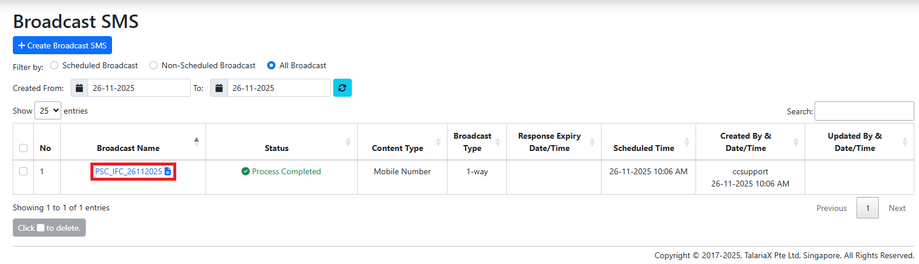
- Verify details
  - Send Mode = sms – TTSH
  - Process Status = Process Complete
  - Confirm correct ‘Message Content’
  - Confirm correct ‘Number of Records’
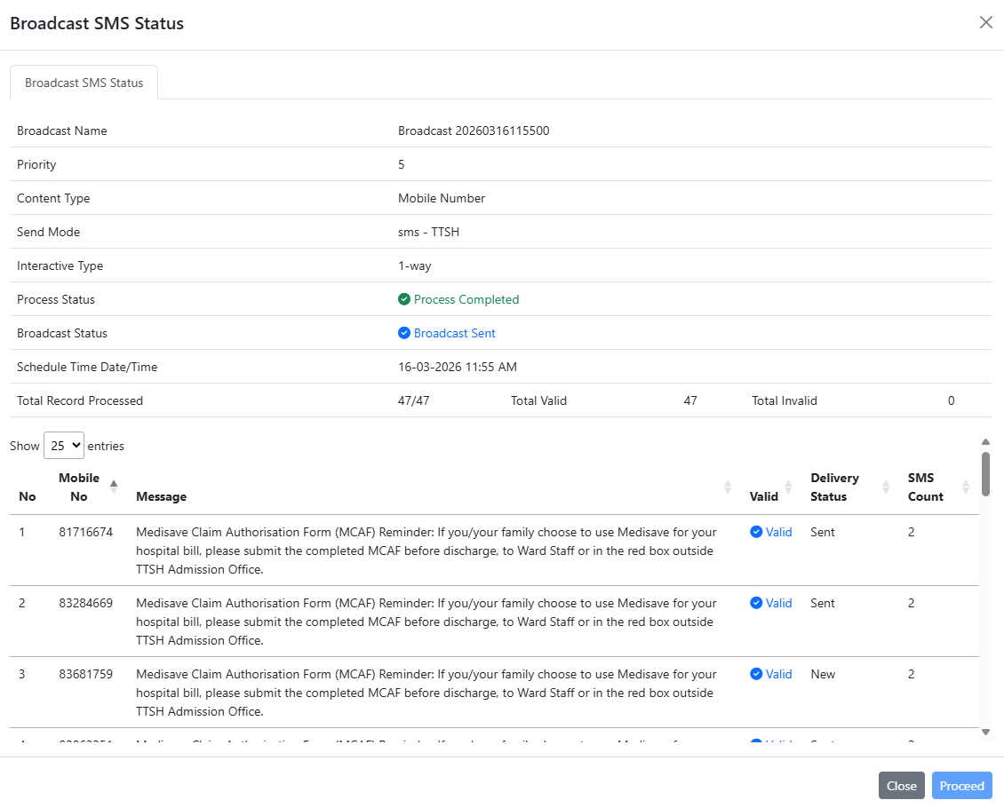

Click ‘Proceed’ to send SMS.*

